**HARSHIT DEVADIGA**

**E015**

**ASSIGNMENT 2**

1. Create percentage calculator for semester IV. User will enter no of courses and click submit button. Those many number fields must be generated dynamically. User will enter marks of each course and the calculate percentage. (Hint: Use DOM methods createElement(), setAttributes(), createTextNode(), appendChild())
2. Create an application to print no of days left for next Christmas(Hint: use date object in js)
3. Create an application to print mouse coordinates.

**QUESTION 1:**

**Code:**

Index.html

<!DOCTYPE html>

<html lang="en">

  <head>

    <meta charset="UTF-8" />

    <meta http-equiv="X-UA-Compatible" content="IE=edge" />

    <meta name="viewport" content="width=device-width, initial-scale=1.0" />

    <title>Document</title>

    <script type="text/javascript" src="script.js"></script>

  </head>

  <body>

    <h3>Percentage Calculator</h3>

    <p>Number of courses:</p>

    <input type="number" id="course_nums" />

    <button onclick="genfields()">Submit</button>

    <br />

    <br />

    <form id="course_form">

      <div id="course_values"></div>

    </form>

    <br />

    <button id="calc-button" onclick="totalpercent()" disabled>

      Calculate Percentage

    </button>

    <p id="result"></p>

  </body>

</html>

script.js

function genfields() {

  let course_nums = document.getElementById("course_nums").value;

  let coursevalues = document.getElementById("course_values");

  coursevalues.innerHTML = "";

  document.getElementById("calc-button").disabled = false;

  for (let i = 1; i <= course_nums; i++) {

    let courseInput = document.createElement("input");

    courseInput.setAttribute("type", "number");

    courseInput.setAttribute("name", "course-" + i);

    coursevalues.appendChild(

      document.createTextNode("Course " + i + " marks: ")

    );

    coursevalues.appendChild(courseInput);

    coursevalues.appendChild(document.createElement("br"));

  }

}

function totalpercent() {

  let courseForm = document.getElementById("course_form");

  let course_nums = document.getElementById("course_nums").value;

  let totalMarks = 0;

  for (let i = 1; i <= course_nums; i++) {

    let courseMarks = parseInt(courseForm["course-" + i].value);

    totalMarks += courseMarks;

  }

  let percentage = totalMarks / course_nums;

  let result = document.getElementById("result");

  result.innerHTML = "";

  let resultText = document.createTextNode(

    "Percentage: " + percentage.toFixed(2) + "%"

  );

  result.appendChild(resultText);

}

**Output:**

**QUESTION 2:**

**Code:**

**Index1.html**

<!DOCTYPE html>

<html lang="en">

  <head>

    <meta charset="UTF-8" />

    <meta http-equiv="X-UA-Compatible" content="IE=edge" />

    <meta name="viewport" content="width=device-width, initial-scale=1.0" />

    <title>Days Left</title>

    <script src="script.js"></script>

  </head>

  <body>

    <h3>Days left for Next Christmas</h3>

    <button onclick="calculateDays()">Calculate Days Left</button>

    <p id="curr_date"></p>

    <p id="result"></p>

  </body>

</html>

**script.js**

function calculateDays() {

  const today = new Date();

  const christmas_date = new Date(today.getFullYear(), 11, 25);

  let convertedtime = 1000 * 60 * 60 * 24;

  const daysLeft = Math.ceil(

    (christmas_date.getTime() - today.getTime()) / convertedtime

  );

  document.getElementById("curr_date").innerHTML = `Today's time: ${today}`;

  document.getElementById(

    "result"

  ).innerHTML = `There are ${daysLeft} days left until Christmas.`;

}

**Output:**

**QUESTION 3:**

**Code:**

**index.html**

<!DOCTYPE html>

<html lang="en">

  <head>

    <meta charset="UTF-8" />

    <meta http-equiv="X-UA-Compatible" content="IE=edge" />

    <meta name="viewport" content="width=device-width, initial-scale=1.0" />

    <title>Mouse Coordinates</title>

    <script src="script.js"></script>

  </head>

  <body onmousemove="mouseCoordinates(event)">

    <h3>Mouse Coordinates</h3>

    <p id="cords">X: 0 , Y: 0</p>

  </body>

</html>

**script.js**

function mouseCoordinates(event) {

  const x = event.clientX;

  const y = event.clientY;

  const cords = document.getElementById("cords");

  cords.innerHTML = "X: " + x + "," + "Y:" + y;

}

**Output:**

Default mouse coordinates:

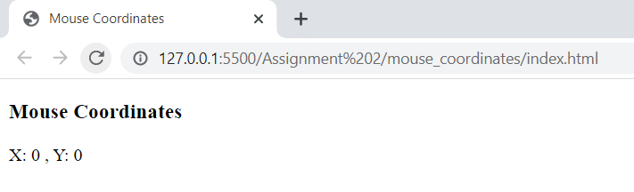

Normal mouse coordinates:

